The Monterey Bay Rosen Method Center
Presents
A RESIDENTIAL ROSEN MOVEMENT INTENSIVE BY THE SEA
On Enders Island at Mystic, Connecticut
Taught by JANE MALEK
Co-taught by ADRIENNE STONE
June 3-7, 2014
https://www.endersisland.com
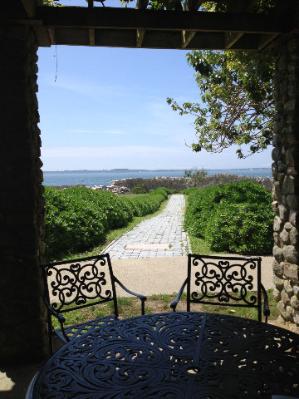
Where: ST. EDMUND’S RETREAT CENTER
ENDERS ISLAND, MYSTIC, CONNECTICUT

When: JUNE 3-7, 2014 (Noon Tuesday – Noon Saturday) (we will plan to meet in the evenings to satisfy 25 hours)
Cost: $875
$225 Non-refundable deposit due Nov. 1st. (Deposit will be refunded only if we or you can fill your space.)
$650 due by April 20, 2013.
This includes, 4 nights lodging (double occupancy), meals and the Intensive. Please Note: At this time registration is limited to the first 12 participants! (If you are interested in a single room, the cost higher and is subject to availability. You must let us know prior to sending in your deposit).
Description:
The 25-hour intensive/ retreat counts toward certification in the Rosen Movement Training and is for those who want to explore all that can happen during the intensive format. Each day will include an hour-long movement class with discussion of how the movements encourage natural, free breathing, increase range of motion, and improve alignment and flexibility. There will be opportunities for everyone to play your favorite music to learn how the music supports the movements. Bring your favorite Rosen Movement music and get ready to have fun. This is a good chance to learn what goes into leading a class with an intimate and supportive group. There will be sound systems for CD’s and iPod connections.

We will discuss the theory of the movements that are based on a solid foundation of physical therapy for prevention. Discover the progression of loosening the muscles and joints that is so simple, yet so effective. We will look at specific parts of the anatomy and explore the emotional component of muscular holding including body readings. With partners we will explore the basics of Rosen Bodywork using touch as a tool to help deepen our awareness of self and others, creating a rich and personal experience. A sharing circle will be a part of the day to help support the inner process of emotional insights that may arise.
Food Preferences:
If you have any dietary concerns or special requests please let us know ASAP. The facility is able to honor gluten free, vegetarian, etc. Please let us know what your needs are when you send your deposit.
Getting There:
The closest airports: Providence, RI Airport and Bradley Airport in Hartford, CT.
Amtrak provides rail service into Mystic Ct.
Driving: approx. 2 ½ hrs from NYC and 2 hrs. from Boston
(see directions on web site)
Contact: Adrienne Stone arstone@optonline.net
Phone: 914 241-0881 or cell- 914-954-3255.
Please email prior to sending your deposit to ensure space is still available.
Mail your deposit to: Adrienne Stone
15 Parkway
Katonah, New York 10536

